Musibraille - new tools for Braille Music learning and writing

Dolores Tomé - University of Brasília – Brazil – dolorestome@terra.com.br

José Antonio Borges - Instituto Tércio Pacitti - Federal University of Rio de Janeiro
Brazil – antonio2@nce.ufrj.br

Abstract
This paper describes the Musibraille Project, where hundreds of people have been trained in Braille Music through a new transcribing and teaching software in Brazil. The methodology can be applied with very modest cultural and technical prerequisites. The software is also free and its operation is very simple for blind or non-blind users. Due to this, the project is producing an extraordinary effect on revitalizing Braille Music in this country.
- Music teaching for blind students in Brazil
  - Braille Music – an introduction
Using Braille Music transcription, a technique invented by Louis Braille, a musical score of any complexity can be transcribed to a tactile format, using an encoding with 6 dots cells, physically identical to the Braille text writing. Representing simple notes and durations is very easy: seven combination of the four upper dots representing notes from Do to Si, and the lowest two points representing basic durations. But unfortunately, a complete music transcription is not so simple.
For every musical signal there is a conventional transcript encoding to the corresponding Braille, and thus the number of symbols used is immense. As there are only 64 combinations of 6 dots (including the space), it is necessary to use multiple cells to some representations. There is also some ambiguity in this encoding. For example, whole notes and sixteenth notes have the same notation, and analysis of the symbol is often contextual.
Historically, musical transcriptions were done by hand, a work of great attention and highly error-prone, and often with the support of a network of volunteers. With the advent of computer technology, some programs were created to facilitate entering text in Braille and as trend, some of which were specializing, incorporating specific functions for typing Braille Music. The programs that allow the transcription of musical texts use the following means (not necessarily all): direct typing; typing into a musical instrument Midi in near real time; automatic transcription of digital music formats, in particular MIDI and Music XML format.
  - Difficulties to get Braille Music scores in Brazil
In culturally developed countries, like United States and German, it is easy to have access to Braille Music Scores, some directly available from public libraries (free of charge or with a small fee). A blind musician can also have access to Braille Music Transcription computer programs and training to use them.
Unfortunately, in Brazil and many other countries, to have access is much more difficult [Tomé, 2004]. There are no Braille Music Public Libraries, and only a few places where trained people are available to do transcriptions. There is a small quantity of music scores available (almost nothing contemporary) and it is difficult to find someone to do transcriptions. So, if a blind person wishes to obtain a single work not available locally, he will have to pay values that can reach tenths or hundreds of dollars, either in an import process, or by paying an institution to transcribe it.
There are some complete programs for Braille Music transcription, but they cost several thousand dollars, value increased by official import taxes. For the Brazilian context, especially when you consider a large-scale deployment, these programs are not for direct use by students.
Almost all the music teachers in music schools are seers, with no knowledge of Braille, and so it is common the refusal of teaching to blind students, as they think that they are not able to transmit the contents of sheet music effectively. Thus, it becomes very difficult for the inclusion of blind musicians in music schools. It is interesting to note that although there are several good blind musicians in the country, almost all of them have no formal training.
In the last 18 years in Brazil, with the introduction of the Dosvox System [Borges, 2009], a very simple but complete computer environment for blind people, the use of computers among visually impaired people is increasing very quickly, now reaching almost 30000 users. Jaws, Virtual Vision, NVDA and other screen readers are also now widespread. However, these systems have been of little aid when the subject is formal music teaching.
- The Musibraille Project
2.1 Main objectives

The Musibraille project intends to create conditions to formal music teaching, giving people with visual impairments, conditions to have a good learning. The strategy of this project is based on:
a) Construction of free software to write and teach Braille Music, and automatically perform simple transcripts.
b) Creating and publishing a web site's library, containing the major works of music education, and a Music Library of Classical and Brazilian music.
c) Training to music teachers and art educators nationwide with a simple methodology, so that they become able to produce relatively medium complexity score transcriptions in a short training time.
2.2 The Musibraille Software

The heart of the project is the Musibraille software which is distributed as part of a kit that contains instructional material on CD and in Braille. The software is designed to be operated by blind or sighted people and embeds a voice synthesizer and a small screen reader to be independent of other products, reducing costs for its spreading.
The program’s main window is divided in two main parts. The upper part contains pure Braille coding (music or text). A transcript is also automatically generated to show a conventional musical score (or a pure text, in some transcriptions), in the lower part of the screen. An optional Quick Access menu is also available to configure the typing and the sound feedback. Figure 1 shows the program main screen.

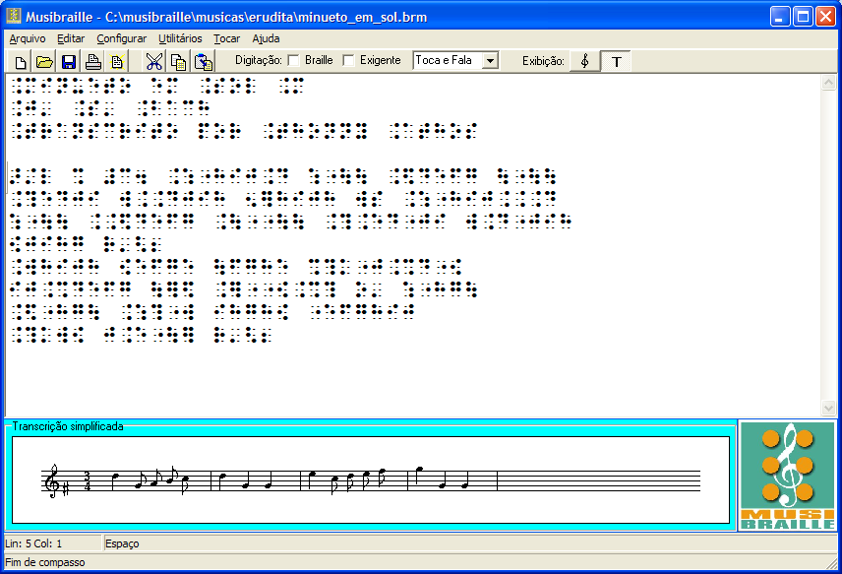
Fig. 1 – Musibraille main screen, described above
The basic operation consist in typing the Braille symbols in a Braille typewriter simulator, and also to use operations like insertion, deletion, modification and movement of musical symbols similar to the conventional text editor. As the music is being produced, the name of the notes in speech synthesis and its sound are produced automatically. Some consistency tests are performed, leading to a reliable transcription. The mouse can be used, but there are keyboard shortcuts for every function.
The file formats are standard to allow exchanges with various programs, both for input and for processing data Braille to other systems. Input can be done by alphanumeric keypad, Simulated Braille keyboard for Midi files or printing standard Braille (BRL) or Music XML. The output can be generated in Midi and Music XML, and the listing in music sheets or in Braille printer, or targeted to print through Microsoft Word.
The software also provides a powerful interactive dictionary of musical symbols and some utilities aimed to the teaching of Music symbols. There are also provided a Text-to-Braille automatic translator, a guitar chord simulation, online exercises, an integrated Music Braille Book, among some other facilities. Thus, a blind or non-blind person can use the software to learn Braille Music interactively.

3 Evaluating the development of the project

3.1 Results obtained by the Project

The educational part of the project was implemented in eight Brazilian states, conducting the training for about 500 people in two years, including teachers and students, blind and seers, causing the revitalization of Braille Music in Brazil. The ease of learning and speed of transcription, obtained through the software, allowed students in a three days course to generate 2 to 5 musical transcriptions of simple scores, without prior knowledge of Braille Music. The transcripts could be made automatically published or consumed in a public digital library, from the software itself.
This project has received wide television coverage, and some technical reports that demonstrate:
- Improved educational aspects in basic education courses, enabling the integration of blind and seer children in the class of musical initiation.
- Increased quality and quantity of sheet music available for conventional musical education for blind people.
- Better education training of classical musicians.
- Integration of blind and non-blind musicians, mediated by the software.

This project had the support of many entities among which stand out the Instituto Tércio Pacitti of Research and Development in Computer Science, from the Federal University of Rio de Janeiro; the University of Brasilia; the State Secretariat of Culture of the Federal District; the Federal District Government; the Ministry of Culture and Federal Government. The project has been financially supported by Petrobras.

References
Borges, J.A – Do Braille ao Dosvox – diferenças nas vidas dos cegos brasileiros – PhD Thesis – COPPE- UFRJ – Rio de Janeiro - Brazil
Opus Technologies (2000)- International Manual of Braille Music Notation
Tomé, D. (2004) – Musicografia braille: instrumento de inclusão – Master Thesis – Univ. Lisboa – Portugal
Tomé, D. and Borges, J.A. – The Musibraille Project – Technical Reports and Documents – from may/2009 to july/2011 – Petrobras – Brazil

